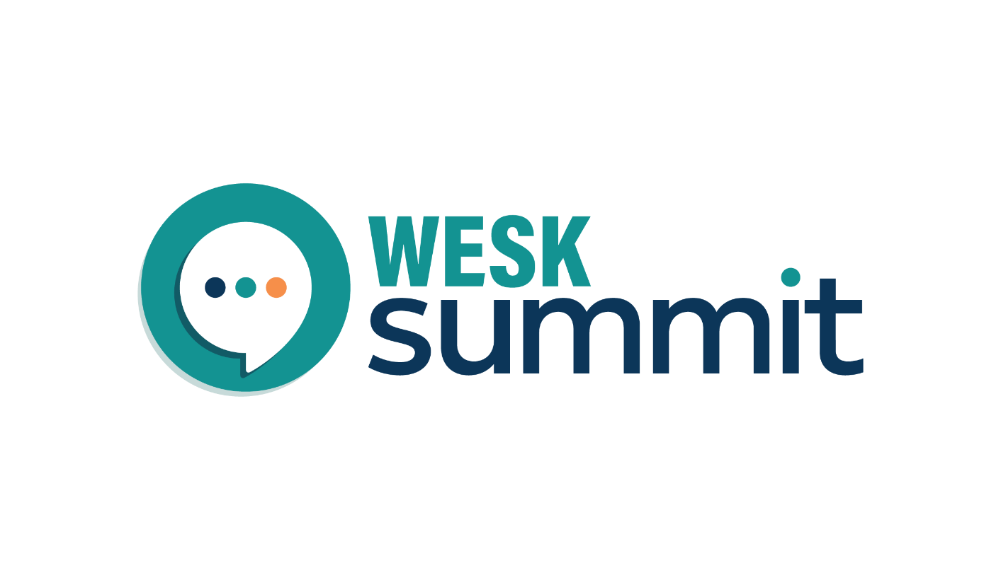

WESK SUMMIT & GALA
WESK’S ANNUAL, PROVINCE-WIDE ENTREPRENEURSHIP CONFERENCE AND AWARDS GALA
MAY 25 & 26, 2022 | SHERATON CAVALIER HOTEL | SASKATOON, SK

PROMOTIONAL PARTNERS PACKAGE

Thank you for supporting WESK as a promotional partner for the WESK Summit & Gala. We’re so thankful for the support we’ve received from our community. With partners like you on board, we’re sure to make this the best WESK Summit & Gala yet!
Did you know that this year will mark the first in-person WESK Summit & Gala since we rebranded from our “Small Business Conference and Celebration of Achievement Gala”? We’re excited to be back and bigger than ever!
As a promotional partner with WESK, you will soon be able to find your logo on our Promotional Partners page here.
To view the below information online, view our Promotional Partners’ Content Hub here.

KEY EVENT INFORMATION:

WESK Summit Gala
Date: Wednesday, May 25, 2022
Time: 5:00pm – 9:00pm
Location: Sheraton Cavalier, Saskatoon
More information: https://wesk.ca/wesk-summit-and-gala/gala/
The WESK Summit Gala provides an opportunity to recognize outstanding female entrepreneurs with one of six Entrepreneur Awards, while also celebrating the achievements of all entrepreneurs in our province.
- Tickets are $115/$145 (early bird/general pricing).
- You can nominate as many women entrepreneurs as you wish.
- Women entrepreneurs can apply themselves if they wish (without a nomination).

WESK Summit
Date: Thursday, May 26
Time: 8:30am – 5:00pm
Location: Sheraton Cavalier, Saskatoon
More Information: https://wesk.ca/wesk-summit-and-gala/summit/
Get ready for the action-packed event of engaging workshops, dynamic keynotes, and important connections. The WESK Summit is your opportunity to collaborate with women entrepreneurs and corporate executives who mean business.
- Tickets are $120/$150 (early bird/general pricing).
- Morning keynote: Zahra Al-Harazi, Award-Winning Entrepreneur; Purpose-Driven Leadership Expert. Learn more about Zahra.
- Afternoon keynote: Barb Stegemann, CEO & Founder, The 7 Virtues; Social Entrepreneur. Learn more about Barb.
- We are currently finalizing our workshop facilitators, of which there will be 6. View our most up to date list of speakers here.

Important Dates
- Early bird tickets launch: January 20, 2022.
- Nominations open: January 20, 2022.
- Nominations close: March 7, 2022.
- Application deadline: March 14, 2022.
- Early bird tickets close: March 30, 2022.
- Finalists announced: April 20, 2022.
- Ticket deadline: May 16, 2022.

Promotional Information
Promotions of the WESK Summit & Gala will run January 20, 2022 through May 16, 2022. May 16 is the final day to purchase tickets. Below, you will find suggested dates, promotional images and suggested copy for the different components of the event.

Social Media Handles
We encourage you to tag WESK’s accounts in your promotional efforts, so that we may engage with your content. Information on our social handles are below.
Social Platform | WESK | WESK Summit
Facebook | @wesk306 | @weskSummit
Instagram | @wesk306 | @weskSummit
LinkedIn | WESK – Women Entrepreneurs Saskatchewan | N/A
Twitter | @wesk306 | N/A

Social Media Content
Click here to download all social media graphics. Having troubles? View all content on the Promotional Partners Content Hub: https://wesk.ca/wesk-summit-promo-content-hub/
We’ve added 2 extra social media posts of our keynote speakers for you to use as you wish.
Time Frame | Suggested Copy | Image Link
January – March 7 | Do you know a POWERHOUSE woman entrepreneur? Nominate her for the WESK Summit Gala awards! 🙌  Awards categories include Community Involvement, Indigenous Entrepreneur, Innovation, Growth & Expansion, Resilience, and Celebration of Achievement. 🏆✨  Know someone who fits the bill? Nominate them today!  https://wesk.ca/wesk-summit-and-gala/gala/  #WESKSummit #WESKSummitGala | Nominations & Applications
January – March 14 | Calling all Saskatchewan woman entrepreneurs! 📣  WESK has opened applications for its entrepreneur awards as part of the WESK Summit Gala! 🏆✨  Awards categories include Community Involvement, Indigenous Entrepreneur, Innovation, Growth & Expansion, Resilience, and Celebration of Achievement. 🥳  Have you gone over and above this year? It’s time you’re recognized! Apply for an award today! 💪  https://wesk.ca/wesk-summit-and-gala/gala/  #WESKSummit #WESKSummitGala | Nominations & Applications
March 1-30 | Time is running out! ⏳  Get your early bird ticket for The WESK Summit before March 30 to receive some SERIOUS savings (a $30 discount!)  <your organization> is proud to be a <partner/sponsor> of this event. On May 26, get ready for an action-packed day of engaging workshops, dynamic keynotes, and important connections.  See the speaker lineup: https://wesk.ca/wesk-summit-and-gala/summit/  #WESKSummit #WESKSummitGala | Earlybird Summit
March 1-30 | Have you gotten your tickets for the WESK Summit Gala yet? Time is running out! ⏳ Purchase before March 30 for $30 in savings!  On May 25, help us celebrate our Saskatchewan women entrepreneurs! At the WESK Summit Gala, you can expect an exciting evening of dinner, networking, and extravagance. 😍✨  <your organization> is proud to be a <partner/sponsor> of this event. Get your ticket today!  https://wesk.ca/wesk-summit-and-gala/gala/  #WESKSummit #WESKSummitGala | Earlybird Gala
March 14 – May 16 | Tickets are now on sale for The WESK Summit! 🙌🤩  <your organization> is proud to be a <partner/sponsor> of this event. On May 26, get ready for an action-packed day of engaging workshops, dynamic keynotes, and important connections. 🚀  The WESK Summit is a great opportunity to collaborate with women entrepreneurs and corporate executives who mean business. 💪  Get yours below!  https://wesk.ca/wesk-summit-and-gala/summit/  #WESKSummit #WESKSummitGala | WESK Summit
March 14 – May 16 | Have you gotten your tickets for the WESK Summit Gala yet? <your organization> is proud to be a <partner/sponsor> of this event. 🏆✨  On May 25, help us celebrate our Saskatchewan women entrepreneurs! At the WESK Summit Gala, you can expect an exciting evening of dinner, networking, and extravagance. 😍✨  Learn more below!  https://wesk.ca/wesk-summit-and-gala/gala/  #WESKSummit #WESKSummitGala | WESK Summit Gala

Email or E-Newsletter Content
Click here to download all E-Newsletter graphics. Having troubles? View all content on the Promotional Partners Content Hub: https://wesk.ca/wesk-summit-promo-content-hub/
Time Frame | Suggested Copy | Image Link
January – March 7 | Do you know a POWERHOUSE woman entrepreneur? Nominate her for the WESK Summit Gala awards!  The WESK Summit Gala provides an opportunity to recognize outstanding female entrepreneurs with one of six Entrepreneur Awards, while also celebrating the achievements of all entrepreneurs in our province.  <your organization> is proud to be a <sponsor/partner> of this event, and we hope you can join us to celebrate our province’s extraordinary woman entrepreneurs over an evening of dinner, networking, and extravagance.  Awards categories include Community Involvement, Indigenous Entrepreneur, Innovation, Growth & Expansion, and Resilience and Celebration of Achievement.  Know someone who fits the bill? Nominate them today!  For more information on the awards categories, and to nominate, visit: https://wesk.ca/wesk-summit-and-gala/gala/ | Gala Option 1  Gala Option 2
February – March 14 | Calling all Saskatchewan woman entrepreneurs! WESK has opened applications for its Entrepreneur Awards as part of the WESK Summit Gala!  The WESK Summit Gala provides an opportunity to recognize outstanding female entrepreneurs with one of six Entrepreneur Awards, while also celebrating the achievements of all entrepreneurs in our province.  <your organization> is proud to be a <sponsor/partner> of this event, and we hope you can join us to celebrate our province’s extraordinary woman entrepreneurs over an evening of dinner, networking, and extravagance.  Awards categories include Community Involvement, Indigenous Entrepreneur, Innovation, Growth & Expansion, and Resilience and Celebration of Achievement.  Have you gone over and above this year? It’s time you’re recognized! Apply for an award today!  For more information on the awards categories, and to apply, visit: https://wesk.ca/wesk-summit-and-gala/gala/ | Gala Option 1  Gala Option 2
March 14 – May 16 | Tickets are now on sale for The WESK Summit!  <your organization> is proud to be a <partner/sponsor> of this event. On May 26, get ready for an action-packed day of engaging workshops, dynamic keynotes, and important connections.  This year’s featured Keynote Speakers include:  - Zahra Al-Harazi, Award-Winning Entrepreneur; Purpose-Driven Leadership Expert  - Barb Stegemann, CEO and Founder of The 7 Virtues, Social Entrepreneur  The WESK Summit is a great opportunity to collaborate with women entrepreneurs and corporate executives who mean business. Grab your ticket while they last!  Learn more at: https://wesk.ca/wesk-summit-and-gala/summit/ | Summit Option 1  Summit Option 2
March 14 – May 16 | Have you gotten your tickets for the WESK Summit Gala yet?  The WESK Summit Gala provides an opportunity to recognize outstanding female entrepreneurs with one of six Entrepreneur Awards, while also celebrating the achievements of all entrepreneurs in our province.  <your organization> is proud to be a <sponsor/partner> of this event, and we hope you can join us to celebrate our province’s extraordinary woman entrepreneurs over an evening of dinner, networking, and extravagance.  Learn more at https://wesk.ca/wesk-summit-and-gala/gala/ | Gala Option 1  Gala Option 2

Thank you to all our Sponsors and Promotional Partners!
We are fortunate to work with a variety of difference partners who share our vision for driving economic growth through by empowering our provinces women entrepreneurs.
To explore further partnership or sponsorship opportunities, contact us today at commincations@wesk.ca.

